SOFTWARE ARCHITECTURE DOCUMENT
© Dassault Systèmes | Confidential Information | ref.: 3DS_Document_2020
Bulk Item-Document Links Widget
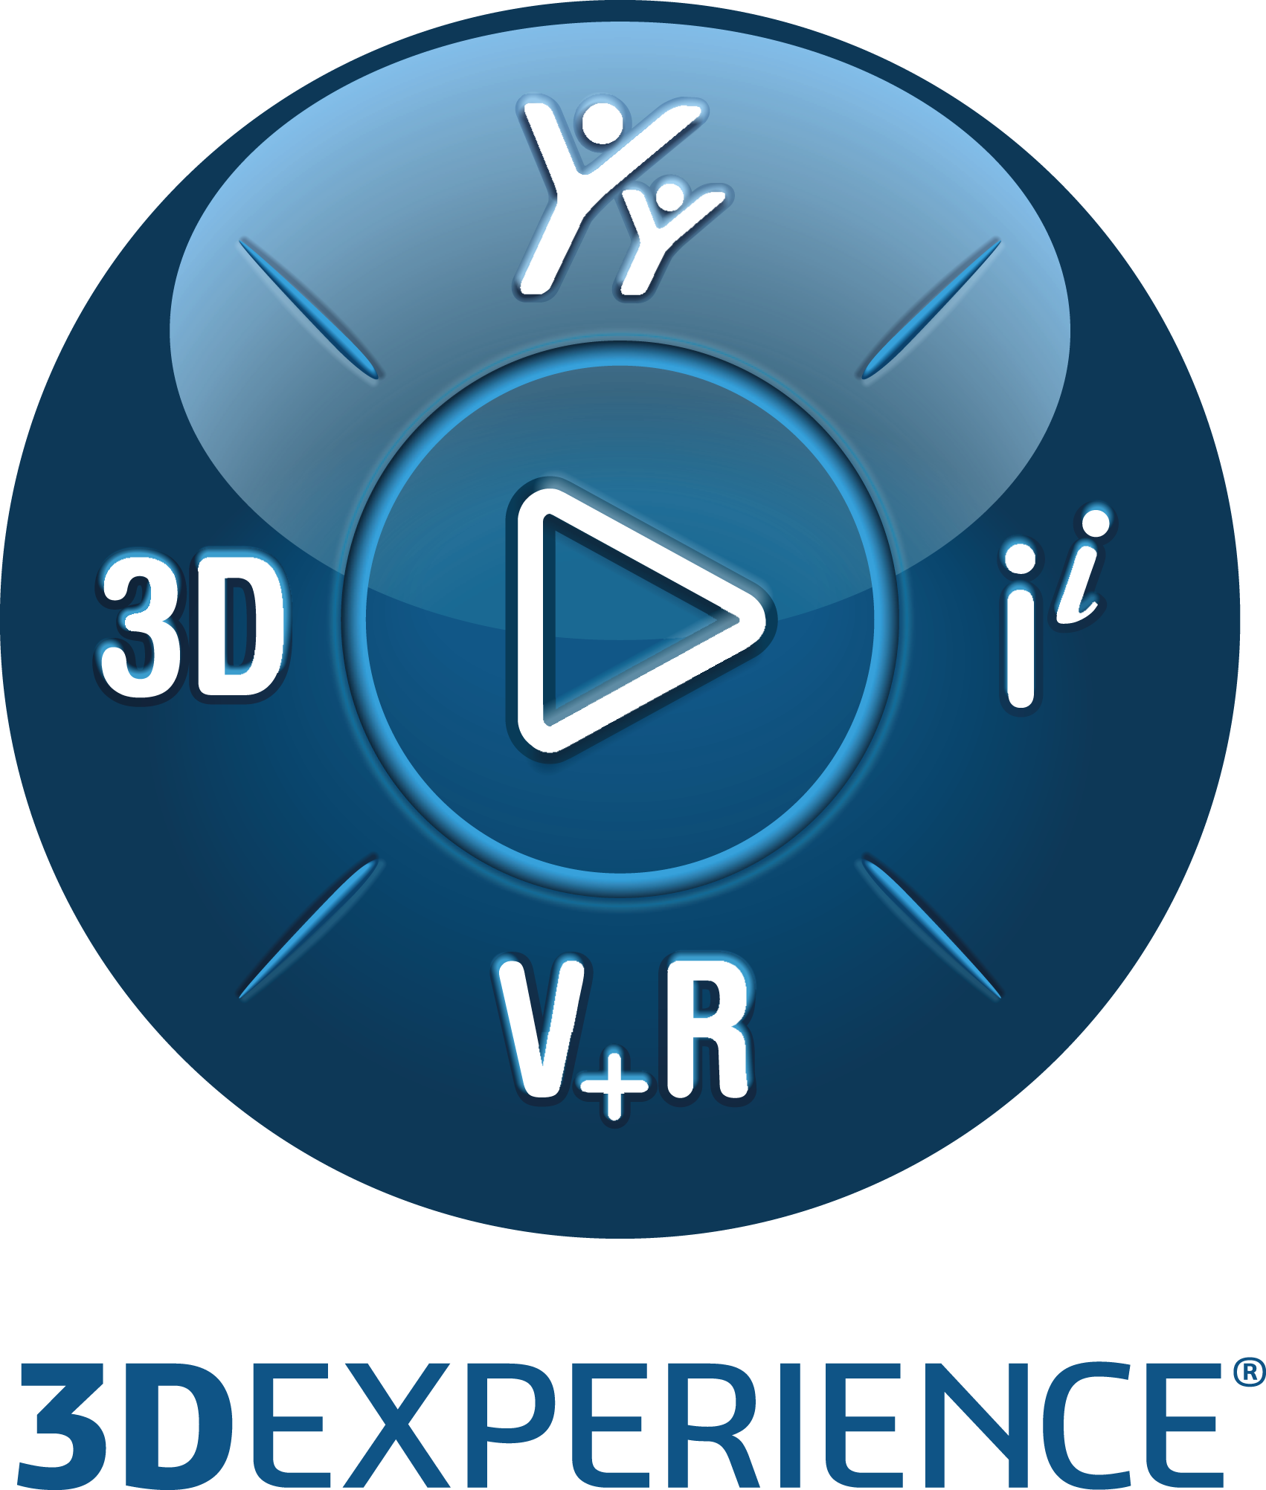

Value Engagement Deliverable (#0302_051)
6/9/2025
Written by: Antonio Nogueira

Validated by:

Table of Contents
Document History 3
2. Introduction 4
2.1. Purpose of the document 4
2.2. Scope of the document 4
2.3. Stakeholder Management 4
3. Functional Overview 5
4. Technical Component Architecture 8
4.1. Development components 8
4.2. Logical components 8
5. Data Model 13
5.1. Read 13
5.2. Write 14
6. APPENDICES 15
6.1. Glossary 15
6.2. External References 15

Document History
Document Location
This is a snapshot of an on-line document. Paper copies are valid only on the day they are printed. Refer to the author if you are in any doubt about the currency of this document.
Revision History
Date of this revision: 09/06/2025 | Date of next revision: -

Revision Number | Revision Date | Summary of Changes | Changes marked
1 | 28/04/2025 | Baseline
2 | 09/06/2025 | Updates that support Change Management for managing Specification relationships. | No
Approvals
This document requires following approvals. Signed approval forms are filled in the Quality section of the PCB.
Name | Title
Distribution
This document has been distributed to
Name | Title

- Introduction
  - Purpose of the document
The aim of this technical specification document is to communicate the software detailed design of the Bulk Item-Document Links Custom Widget created for Ariston in order to satisfy requirements expressed under ER135596.
- Functional Overview
The main use cases that the custom widget needs to implement are:
- UC1 - Associate a document to multiple items
  - Attach a document to multiple items at once.
  - Add a document as specification to multiple items at once.

- UC2 - Remove document association from multiple items
  - Detach a document from multiple items at once.
  - Remove a document as specification from multiple items at once.

- UC3 - Replace document association associated to multiple items
  - Replace a document attached to multiple items at once.
  - Replace a document assigned as specification to multiple items at once.

A couple of solutions to satisfy these requirements was presented and discussed with Ariston (see Custom Widget – User Interface Design.pdf – v1.0). The second option was selected by Ariston. The relevant mockups that apply to that option are displayed next.
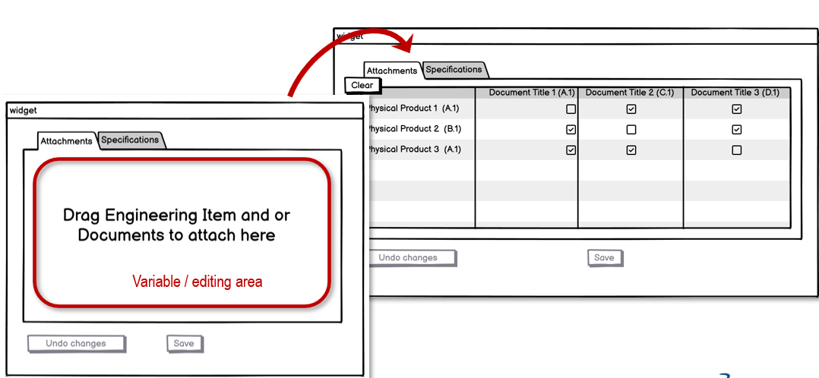
Figure 1 – Main User Interface Mockup
e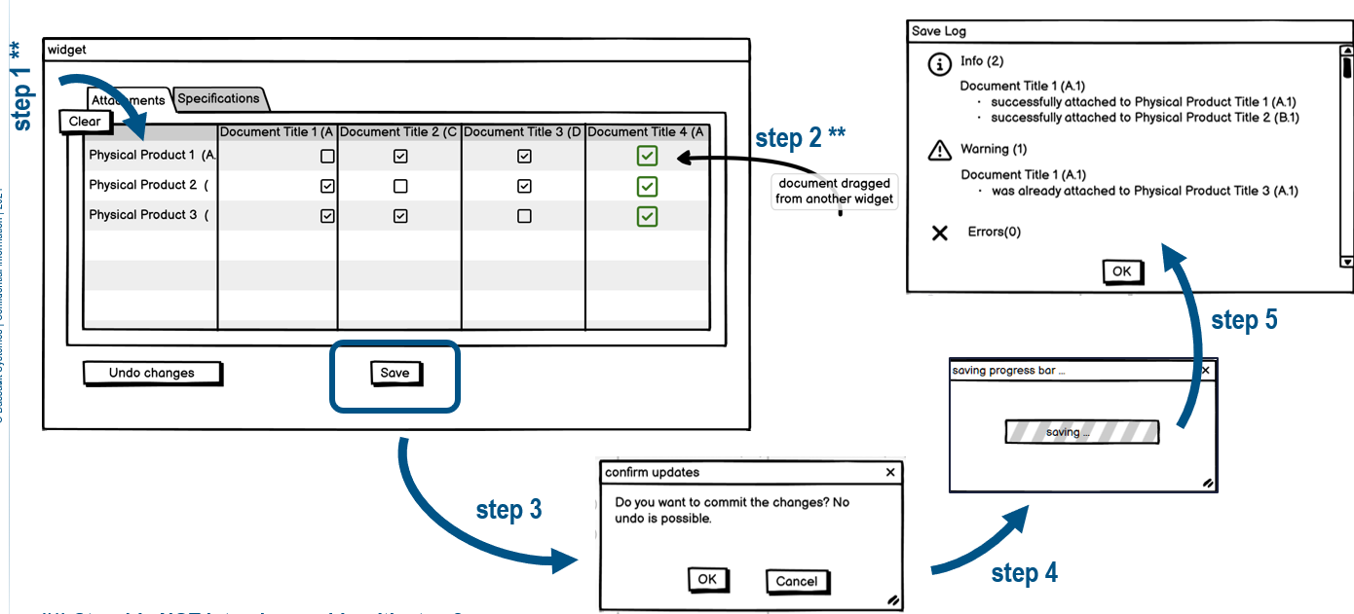
Figure 2 – Steps to attach a document to multiple items at once

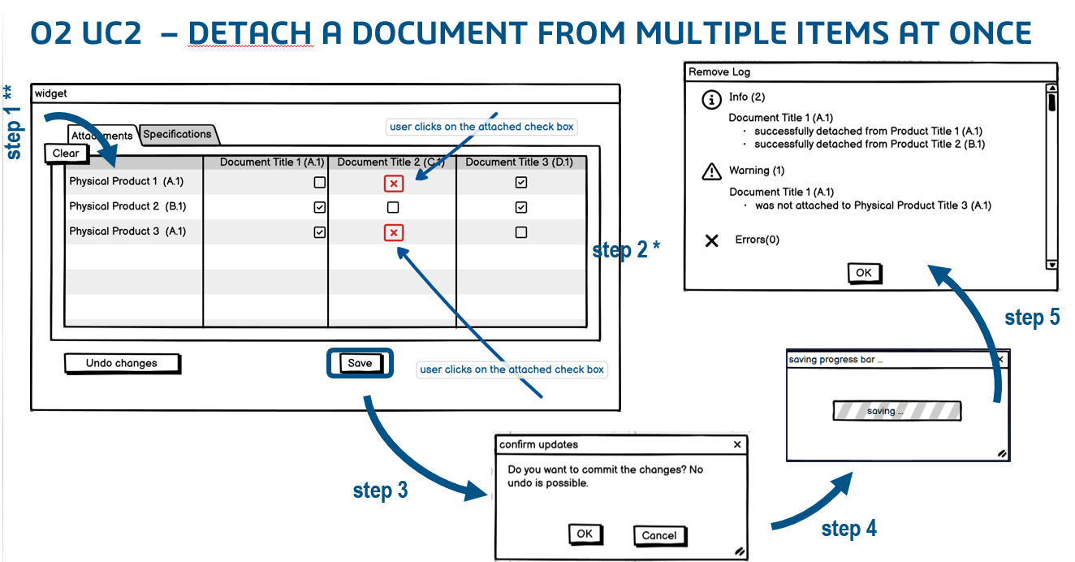
Figure 3 - Detach a document from multiple items at once
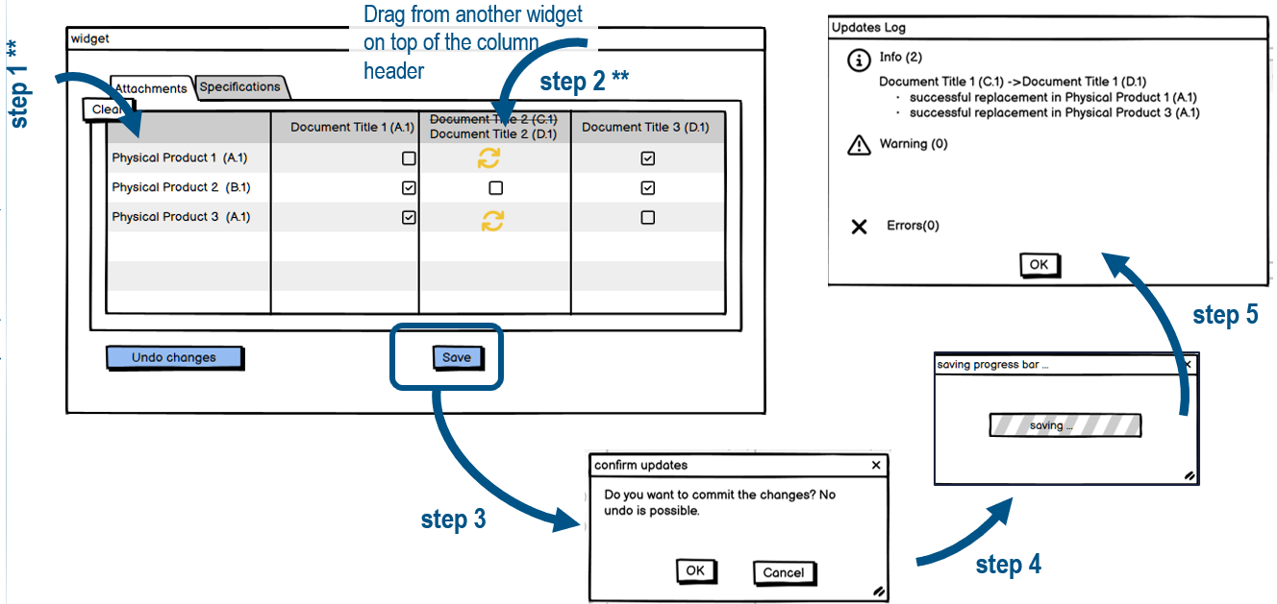
Figure 4 - Replace a document from multiple items at once
    - Additional Observations
- relies on dragging items and/or documents from other widgets as a form of selection

- Transactions are not immediate. They require user confirmation, save and at the end a log/report.

- Saving might require some time as there are no bulk document web service operations available.

- It requires time for checking documents associated.

- Frontend only (no backend required).

- The interface of the final log, displayed to the user at the end of each use case, should allow copying the Physical Product titles.

- Technical Component Architecture
  - Development components
The Custom Widget development dependencies are described in the following diagram.
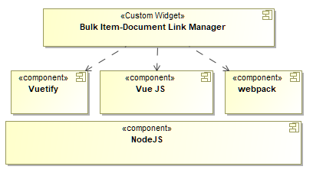
Figure 5 - Custom Widget Development dependencies

The final compilation (transpilation to be precise) brings all of the javascript logic under a single bundle.js file together with a number of static media files, that end up making the actual distributed set of files.
  - Logical components
The next diagram shows the main logical components of the Custom Widget and their inter-dependencies (dashed arrows). The components can be logically divided in two main structural types; UI Components and Web Service Util components.
    - UI Components
The UI components implement the graphical interface that the human operator uses to perform the required use cases as defined in the “Custom Widget – User Interface Design.pdf” as well as their logic. These components have been implemented using the VueJS (options based) framework and reusing, for the great part, Vuetify components. There are three main UI components according to their roles and responsibilities as explained in more detail next.

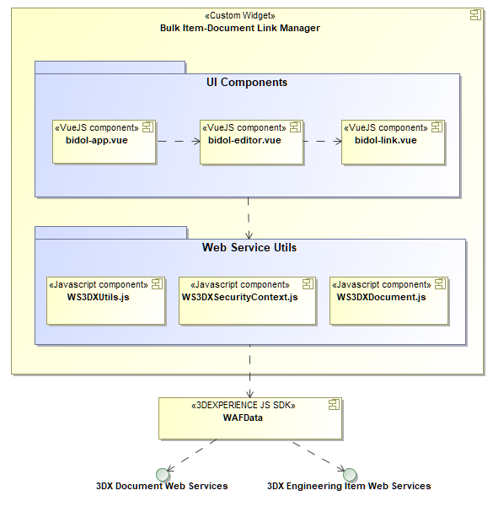
Figure 6 - Internal logical architecture
      - bidol-app.vue
- Implements the main frontend widget user Interface.
- Coordinates the active editor component (ie. either the attachments links editor or the specification links editor – there can only be one active at any one time)
- Triggers and implements the SAVE functionality
- Triggers and implements the UNDO functionality.
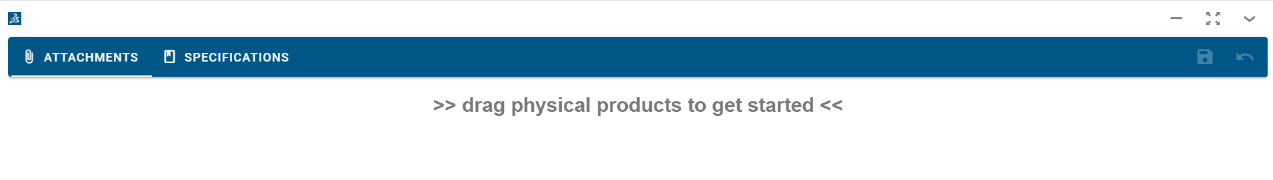
Figure 7 Main application frontend User Interface

The main vuetify or other type of sub-components of the application, in terms of the bidol-app user interface, are further described in the next diagram.
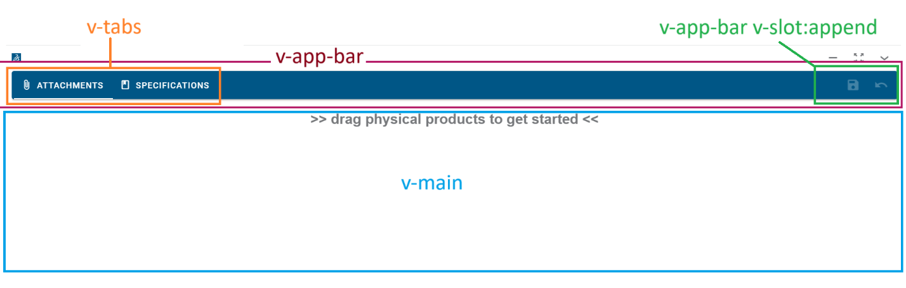
- v-app-bar - hosts the main tab selectors (v-tabs) that allow to switch between the two editors (ie. attachments and specifications). It also hosts a couple of buttons for SAVE and UNDO in its template append slot. It also hosts a number of other dialogs related to the save process that are shown to the user on different activations.
- v-main - hosts the UI of the main active editor (ie. either Attachments or Specifications).
      - bidol-editor.vue
Once an item (engineering item) is dropped into the main empty editor, a matrix/table is presented to the user showing the link states (either attachments or specifications) between each item and associated document, if any.
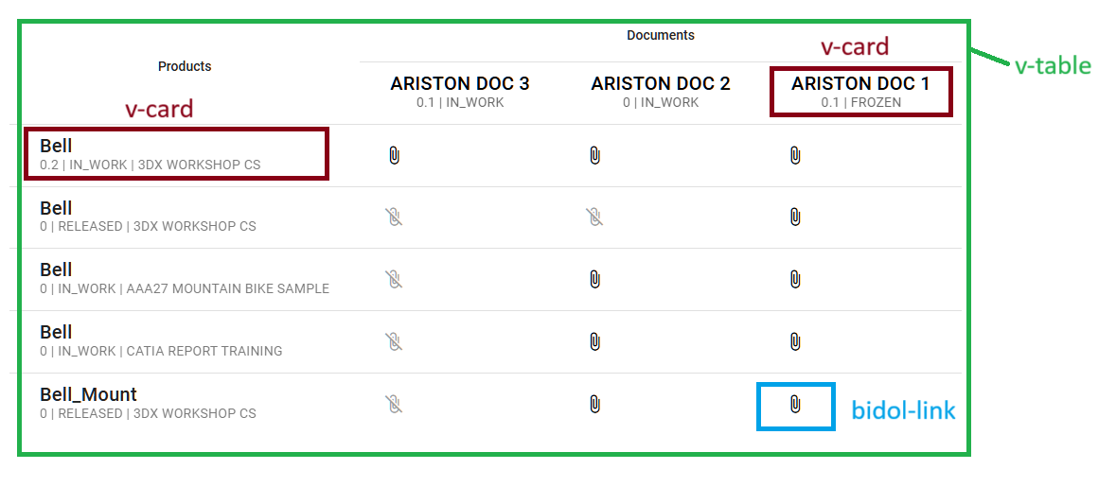
Figure 8 - main links editor
The main vuetify components in the editor are shown on the picture above. Each logical link state between an item and a document is a custom component we called bidol-link.
Editing use cases:
- The links in the table can be edited by the user using two different methods:

- Multiple method – by column header selection - i.e. the user clicks on the table column header and all of the links in the column change consistently.

- Individual method – by directly by clicking on each individual link icon
Links edited with the individual method b are visually identified by an additional dot marker on the upper right of the link icon state. 
Note that method a) does not override change the state of links changed with method b). The reverse however is true.

- Dropping an engineering item - Dropping one or more engineering items from another 3DEXPERIENCE widget into this table is the first necessary step. The table will display the engineering item title, revision, state and collaborative space in the first line of each row. Any associated documents (i.e. attached or specifications) will be also displayed in columns.

- Dropping a new document into the table – At least one engineering item needs to have been dropped into the table otherwise an error will be displayed. So, when a new document is dropped into the table a new column will be added for this document and by default all of its links will be marked for creation. If additionally, this new document is dropped over an existing document header all of the existing links in that column will be marked for deletion (replacement use case).
      - bidol-link.vue
Manages each individual link between an item and a document. The link can represent either an individual document attachment or specification. A table describing the link states and the corresponding icon color and representation (for the attachment case) is shown below
Link icon | State Description
 | A link between the item and the document exists in 3DXPERIENCE.
 | A link between the item and the document doesn’t exist in 3DXPERIENCE.
 | A new link between the item and the document will be created in 3DEXPERIENCE upon successful save.
 | An existing 3DEXPERIENCE link between the item and the document will be deleted upon successful save.

State transitions – the following are the possible transitions
Previous State | Next State | Transition Description
 |  | An existing link in 3DEXPERIENCE can only be changed to a “to be deleted” state.
 |  | A link that doesn’t exist in 3DEXPERIENCE can only be transition to a “to be created” state.

- Data Model
This section describes the most important data elements in this solution. Data is retrieved and saved back to 3DEXPERIENCE through the standard 3DEXPERIENCE web services using the 3DEXPERIENCE Javascript SDK (aka WAFData).
The main data container variables are managed by the editor.vue component, explained in more detail next.
  - Read
The data that represents the engineering items and any associated documents (either through attachment or specification links) is read at the time the user drops the data from a different widget in the 3DEXPERIENCE interface into the custom widget.
    - itemDocs
it holds all of the engineering items and the documents associated to each of them. It is used to display the rows of the table in the editor view. It is loosely described by an array of objects of the following type:
"type": "object",
"properties": {
"item": {
“description”: “engineering item data as retrieved from 3DEXPERIENCE”
“type”: “object”
},
“docs”: {
“description”: “documents associated to an engineering item as retrieved from 3DEXPERIENCE”
“type”: “array”
},
“changeStatus”: {
“description”: “includes the latest updated change compatibility status – applicable only for the specification editor that requires change control functionality”
“type”: “object”
},
    - documentData
it holds an array of all (non-duplicated) documents that are retrieved either from a) being associated to one or more of the engineering items or b) from direct user selection from direct drag & drop to the widget. It is used to display the columns of the table in the editor view. It is loosely described by an array of objects of the following type:
"type": "object",
"properties": {
"caption": {
“description”: “the document title displayed in the column header”
“type”: “string”
},
“id”: {
“description”: “the document 3DEXPERIENCE physical id”
“type”: “string”
},
“value”: {
“description”: “the document data as retrieved from the 3DEXPERIENCE web services”
“type”: “object”
},
“overrideInitialState”: {
“description”: “true if it was dragged by the user and there is no association with an engineering item in the table, false otherwise”
“type”: “boolean”
},
“selectMode”: {
“description”: “selection mode associated to the user selection of the column header”
“type”: “integer”
},
“class”: {
“description”: “class to be applied to the column header”
“type”: “string”
},
“color”: {
“description”: “color to be applied to the column header”
“type”: “string”
},
  - Write
The main functionality of the widget is to allow users to create new or delete existing links (attachments or specifications) between engineering items and documents in 3DEXPERIENCE. Data is temporarily changed by the user in the custom widget working session and changed in 3DEXPERIENCE upon the save request.
For specifications only: If there is a change action active, then the creation or deletion of these links will be done under that change action control.
    - creationPendingRequests
Holds array of links waiting to be created. Called by SAVE to create new links in this array. The objects in the array are of the following type
"type": "object",
"properties": {
"productId": {
“description”: “3DEXPERIENCE engineering item physical id”
“type”: “string”
},
“documentId”: {
“description”: “3DEXPERIENCE document physical id”
“type”: “string”
}
    - deletionPendingRequests
Holds array of links waiting to be deleted. Called by SAVE to delete any existing links in this array. The objects in the array are of the same type than that of the creationPendingRequests array.

- APPENDICES
  - Glossary
ACRONYM | DEFINITION
3DX | 3DEXPERIENCE
DS | Dassault Systèmes
N/A | Not Applicable
OOTB | Out Of The Box
WS | Web Services
  - External References
Document | Version | Description
Custom Widget – User Interface Design.pdf | 1.0 | Exploration of two major solution concepts for the widget.

